**Greenwood College**

**Semester Two Examination, 2018**

**Question/Answer Booklet**

**MATHEMATICS APPLICATIONS**

**UNITS 1 AND 2**

## Section One:

## Calculator-free

Your name

## Time allowed for this section

Reading time before commencing work: five minutes

Working time: fifty minutes

## Materials required/recommended for this section

***To be provided by the supervisor***

This Question/Answer booklet

Formula sheet

***To be provided by the candidate***

Standard items: pens (blue/black preferred), pencils (including coloured), sharpener, correction fluid/tape, eraser, ruler, highlighters

Special items: nil

## Important note to candidates

No other items may be taken into the examination room. It is **your** responsibility to ensure that you do not have any unauthorised material. If you have any unauthorised material with you, hand it to the supervisor **before** reading any further.

## Structure of this paper

|  |  |  |  |  |  |
| --- | --- | --- | --- | --- | --- |
| Section | Number of questions available | Number of questions to be answered | Working  time (minutes) | Marks available | Percentage of examination |
| Section One:  Calculator-free | 8 | 8 | 50 | 52 | 35 |
| Section Two:  Calculator-assumed | 13 | 13 | 100 | 98 | 65 |
|  | | |  | **Total** | 100 |

|  |  |  |
| --- | --- | --- |
| Markers use only | | |
| Question | Maximum | Mark |
| 1 | 5 |  |
| 2 | 5 |  |
| 3 | 7 |  |
| 4 | 8 |  |
| 5 | 6 |  |
| 6 | 7 |  |
| 7 | 6 |  |
| 8 | 8 |  |
| S1 Total | 52 |  |
| S1 Wt (×0.6731) | 35% |  |
| S2 Wt | 65% |  |
| Total | 100% |  |

## Instructions to candidates

1. The rules for the conduct of examinations are detailed in the school handbook. Sitting this examination implies that you agree to abide by these rules.

2. Write your answers in this Question/Answer booklet.

3. You must be careful to confine your response to the specific question asked and to follow any instructions that are specified to a particular question.

4. Supplementary pages for the use of planning/continuing your answer to a question  
have been provided at the end of this Question/Answer booklet. If you use these pages to continue an answer, indicate at the original answer where the answer is continued, i.e. give the page number.

5. Show all your working clearly. Your working should be in sufficient detail to allow your answers to be checked readily and for marks to be awarded for reasoning. Incorrect answers given without supporting reasoning cannot be allocated any marks. For any question or part question worth more than two marks, valid working or justification is required to receive full marks. If you repeat any question, ensure that you cancel the answer you do not wish to have marked.

6. It is recommended that you do not use pencil, except in diagrams.

7. The Formula sheet is not to be handed in with your Question/Answer booklet.

Section One: Calculator-free 35% (52 Marks)

This section has**eight (****8)** questions. Answer **all** questions. Write your answers in the spaces provided.

Working time: 50 minutes.

Question 1 (5 marks)

(a) Solve the equation for . (2 marks)

(b) Ash, Billie and Chris collected a total of cans to recycle. Ash collected twice as many cans as Chris, Chris collected more cans than Billie and Billie collected cans.

Determine how many cans Billie collected. (3 marks)

Question 2 (5 marks)

The number of job applications per day received by a company over a period of consecutive days are listed below:

(a) Determine the five-number summary for this data. (3 marks)

(b) Use the five-number summary to construct a box-plot on the scale below. (2 marks)



Question 3 (7 marks)

(a) The graph of is shown below. Determine the values of and . (2 marks)

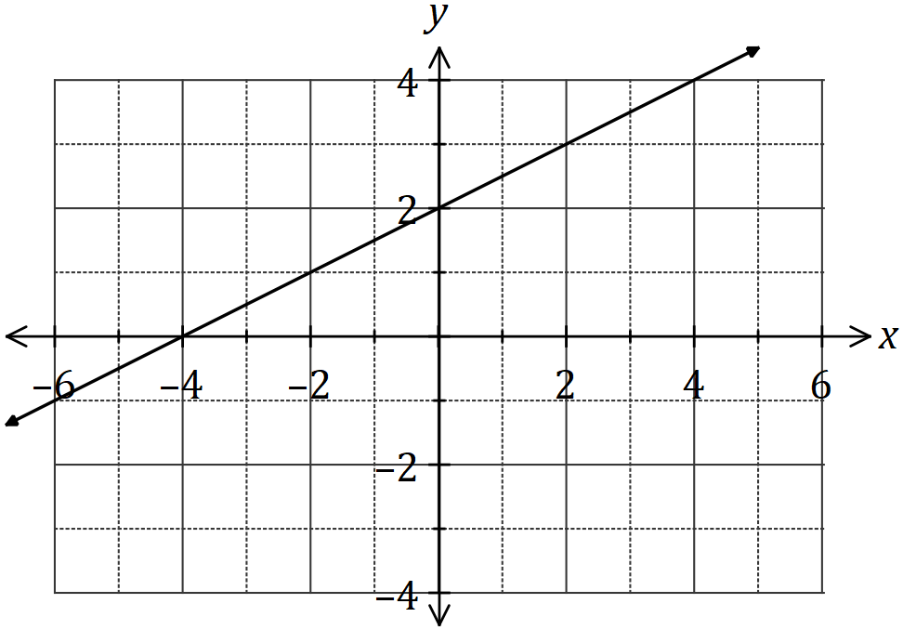

(b) Draw the graph of the line on the axes below. (3 marks)

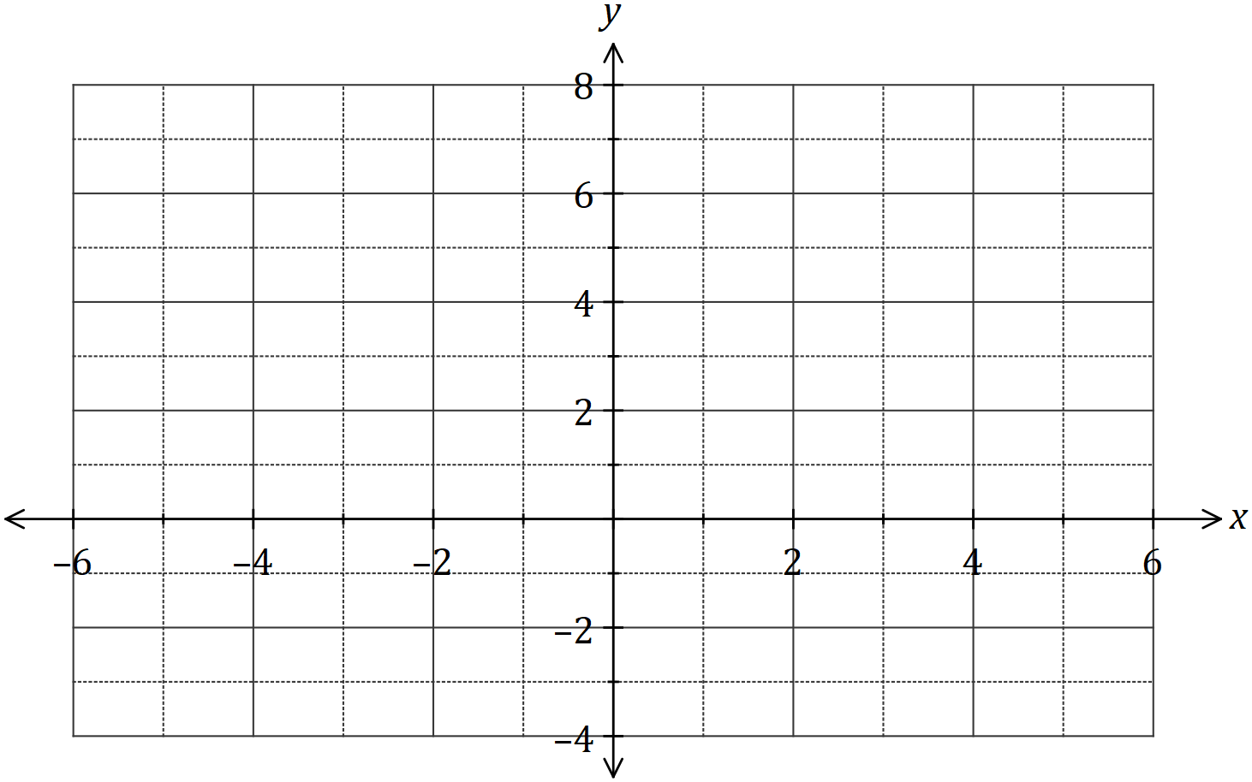

(c) Determine the gradient of the line . (2 marks)

Question 4 (8 marks)

(a) The power consumed by a device can be calculated using the formula .

Calculate the value of when

(i) and . (2 marks)

(ii) and . (2 marks)

(b) The variable is related to diameters and by the formula .

Calculate the value of when

(i) , and . (2 marks)

(ii) , and . (2 marks)

Question 5 (6 marks)

Consider the matrices .

(a) Determine . (1 mark)

(b) State the size of the row matrix. (1 mark)

(c) Calculate, where  is the identity matrix. (2 marks)

(d) i) Calculate *2A* (2 marks)

ii) Determine the values of  if 

Question 6 (7 marks)

(a) The lines with equations and are shown on the axes below.

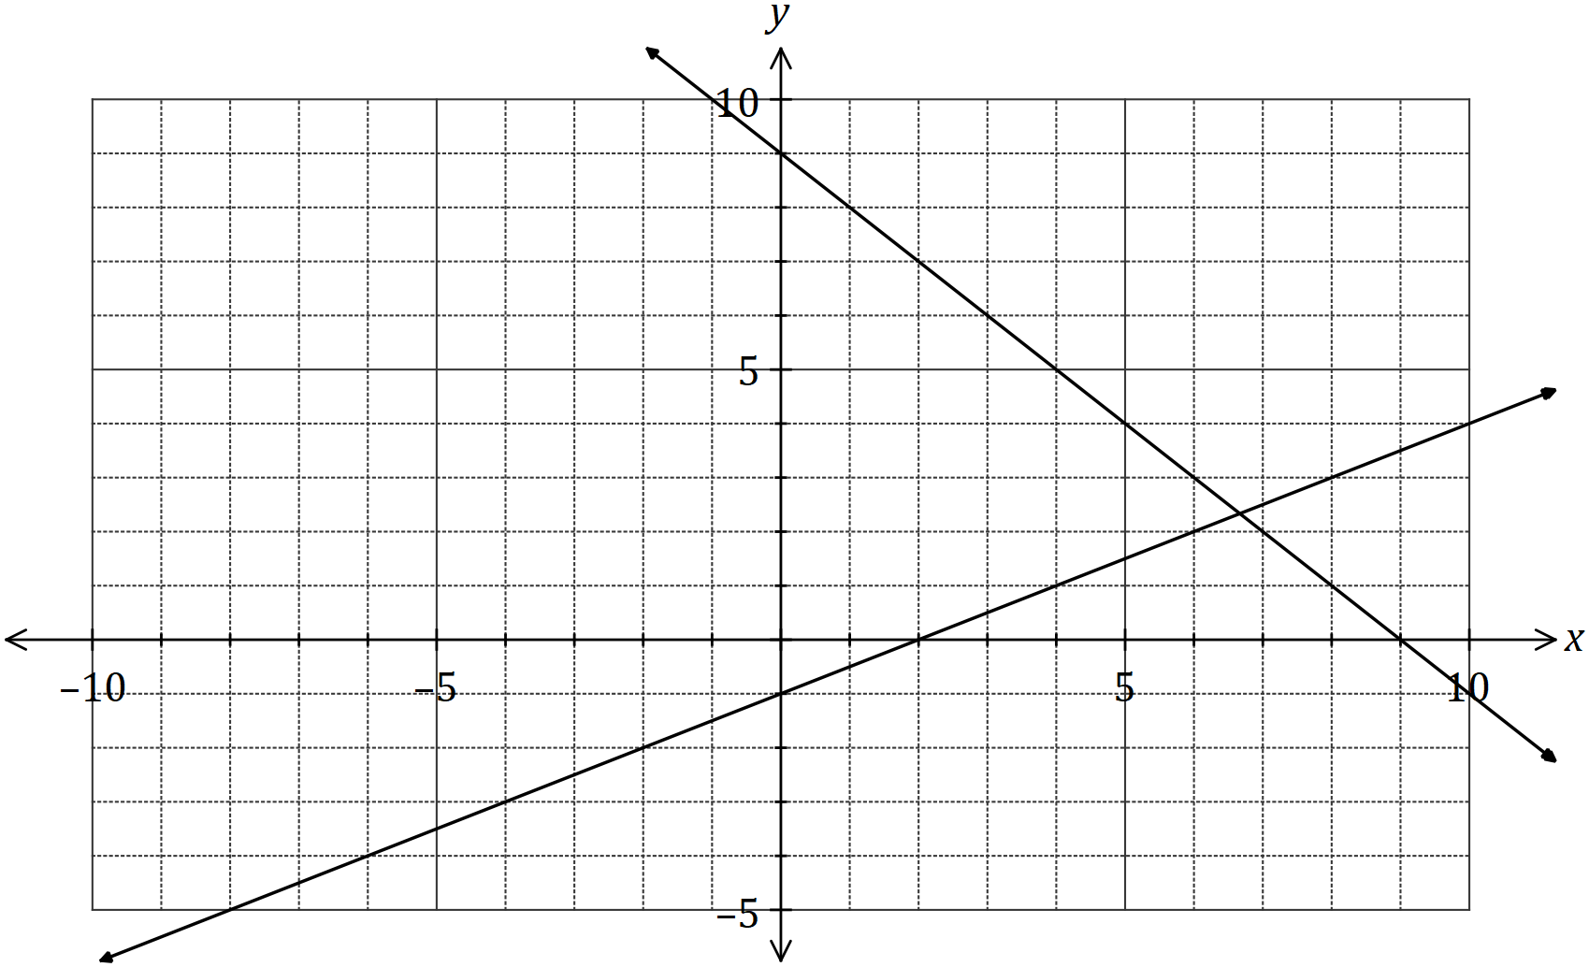

(i) Draw the line on the axes above. (2 marks)

(ii) Solve the simultaneous equations and . (2 marks)

(b) Solve the simultaneous equations and . (3 marks)

Question 7 (6 marks)

The heights of -year old girls are normally distributed with a mean of and a standard deviation of .

(a) Use the rule to determine the approximate percentage of -year old girls that can be expected to have heights between

(i) and . (2 marks)

(ii) and . (2 marks)

(b) Nurses at a health clinic measure the heights of children and refer anyone with a height that is more than three standard deviations from the mean of the child's age group to a doctor.

The last ten girls, aged , who attended the clinic had the following heights:

Determine, with justification, how many of these girls were referred. (2 marks)

Question 8 (8 marks)

A group of friends who frequently travelled abroad exchanged foreign currency between themselves using the conversion table below.

The following trades were made using this table : dollars were exchanged for dinars

and kroner were exchanged for dollars.

|  |  |  |  |  |
| --- | --- | --- | --- | --- |
| Country/Currency | Australian/Dollar | | | |
|  |  |  |  |
| Denmark/Krone |  |  |  |  |
| Japan/Yen |  |  |  |  |
| Kuwait/Dinar |  |  |  |  |
| Thailand/Baht |  |  |  |  |

(a) How many baht can be exchanged for dollars? (1 mark)

(b) How many dollars can be exchanged for yen? (2 marks)

(c) Before travelling to Kuwait, one of the group exchanged dollars for the local currency. How many dinars did they receive? (2 marks)

(d) Another member of the group exchanged dollars for a mixture of kroner and some yen. Determine the amount of Japanese currency they received. (3 marks)

Supplementary page

Question number: _________